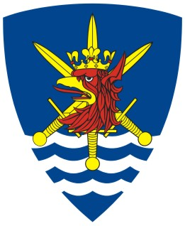

Celebrations

of the 10th Anniversary

of Multinational Corps Northeast

19-20 September 2009

Accreditation form

Please fill in the accreditation form and send it to the Public Affairs Office
contact@hqmncne.mil.pl

Fax +48 91 4445 957

No | Name of media agency | Names of journalists, cameramen, photographers | E-mail address | ID  (Type and Number) | Mobile phone

Participation in the second day of the celebrations at Baltic Barracks: YES NO

